Test Scenario for the PITS#12167 – “The system is generating two cancel

reports on each leg for the order.”

Test Setup

- NONE

Test Case:

- Created a spread order with leg ratio 2:5 and direct route it to Par workstation W903,
- For the Par workstation W903, select the order and click on the BOOK button, the order should stay at the W903 because of the ratio strategy.
- Click on the CANCEL button to cancel the order.

Verification:
- From the order status window, select OrderHistory menu item from the popup window by right-mouse click on the order.

- From the list of order history events, you should only see one event type 2 (package level cancel event) and two event types 52 (one for each spread leg) for the order.

Test Scenario for the PITS#12239 – “Failed on PAR forced logged off after the CXL request failed routing to OMT due to the product state closed.”

Test Setup

- Set Booth Default OMT as B311 for the routing property.
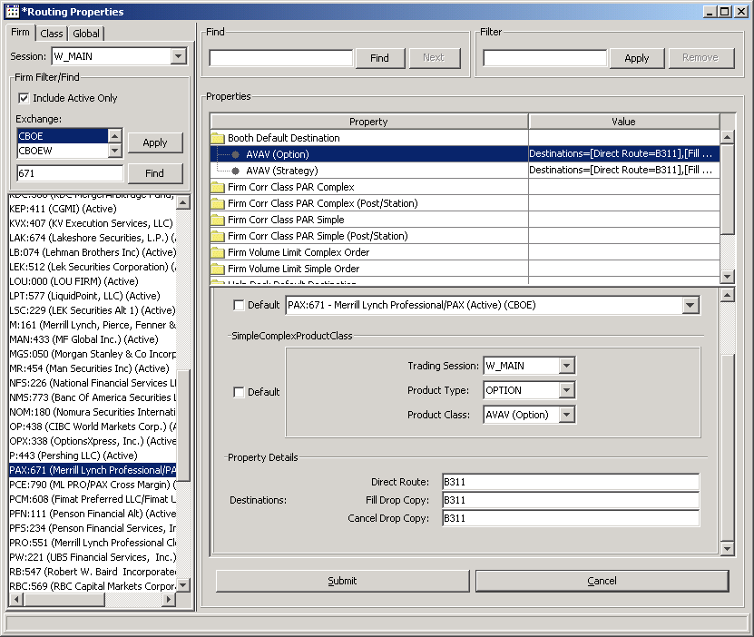

Test Case

Create a simple order and direct route to PAR Workstation W903
- From the workstation W903, select the order and click on the print button, then the dialog box is populated. Don’t click PRINT button yet.
- Log on the PAR Adapter host and type the following command
pstop PID (Par Adapter process id)
- From the Trader GUI, create a cancel replace request on the order.
- Click the PRINT button on the dialog box – the order should be routed to the OMT B311.
- From the SA GUI, close the product on the order.
- Release the PAR Adapter by typing “prun PID(Par Adapter process id).
- Log onto the BC box and run the ar command as the following
ar OHServerHybrid forcedLogoffParWorkstation W903

Verification:
- You should see the replacement order at the OMT B311 along with the original order.

Test Scenario for the PITS#11202-“ System Exception on Order History Query”

Test Setup
Setup Booth Default OMT B311 and HelpDesk OMT H300

Test Case

- Select a class symbol available on both Sessions, W_MAIN and ONE_MAIN
- Create a spread order in W_MAIN and another spread order in ONE_MAIN and send both orders to Booth Default OMT.
- Log in a HelpDesk OMT and query the orders by location B311.

Verification

- You should see the two orders from the query from the HelpDesk OMT H300.

Test Scenario for the PITS#12145-“ When OPS was forcing off Par workstations via the System Health Monitor, W363 on prdbc97b (PAR 9) would not be forced off”

Test Setup
Setup Default Booth OMT to B311

Test Case
- Create a spread product with 7:7:100
- Create a buy/write order with quantity 11 and send to Par workstation W903
- Manually trade the order with ratio 74/74/1050 at the workstation W903
- From the BC command line, type the ar command as follows
ar OHServerHybrid forcedLogoffParWorkstation W903

Verification
The order should be routed to the OMT B311.

Test Scenario for the new future – “Reject a spread order with more than 4 legs

Test Setup

NONE

Test Case

- Create a spread order with more than 4 legs.

- Received the DataValidationException immediately from the Trader GUI.

Test Scenario for the PITS#11560-“ Undelivered ETN Rejects to PO34”

Test Setup

- From SAGUI, set Firm Property name ETN Parameter to “Y” as follows;

Test Case

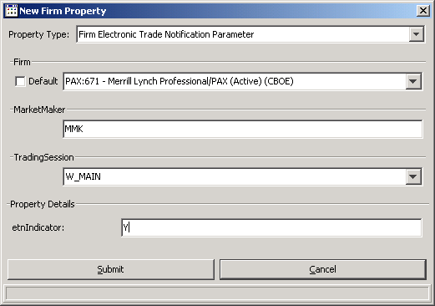

- Test Scenarios cannot be executed manually; they require a testing tool/simulator to enter the trade transactions from the NCC Broker side
- NCC Brokers used in the tests should be registered for an Alias which IP is recognized by the MMHH Server (AP) in order to enter the ETN rejects/accepts/Trade updates, deletes
- Tester will need to have PAR workstation with user id JS/CBOE, Trader and SA GUIs set
- Verification of last sale should be done in Trader Gui/ Market Data History for that product
- Set Routing Property: Session/Firm: Crowd Default Destination for your Firm/Class to B002(B002 user role is Booth OMT) in order to receive the ETN rejects, don’t log in the B002

Test Scenario: OHS generates an ETN for PAR Trade. NCC user rejects the ETN

CUST1 enters an order: Sell 1.25 x100 with Direct Route to PAR
PAR Broker fills the order manually against contra MM (ABH)
OHS receives the fill and determines that the contra party ABH ETN Parameter is “Y”

Verification:
a. OHS generates an ETN and sends it to MMHH server via MMHH adapter -> NCC user
b. Verify MM HH user receives an ETN for 100 @ 1.25, Contra Acronym JS, product ABB Dec 07 30 Call
c. Verify last sale for 100 @ 1.25 in MDH in Trader GUI, Broker JS, Contra Broker ABH

NCC user rejects the ETN
Verification: ETN reject should go to the Crowd OMT, but since the Crowd OMT is not logged in, the text message including UNREACHABLE DESTINATION B311 should go to helpDesk OMT if the helpdesk Omt is set as alternate destination and is logged in, otherwise the ETN reject messgage should go to SAGUI.
PITS11947:
Set up the Reasonability edit range to be Group A
Set the market 2.8 – 3.0 X 100
Route a simple order with price 3.6
Since the new code is using the market to calculate the edit range, the maximum super marketable range will be 0.5. So this order will fail reasonability edit. If it was the old code, the range would have been 1.0 (from the order’s price the range was calculated)
Group “A”
Range Price Check $
0-3 $0.50
3.01-10.00 $1.00
10.01-30.00 $1.50
30.01-50.00 $2.00
50.00 + $3.00
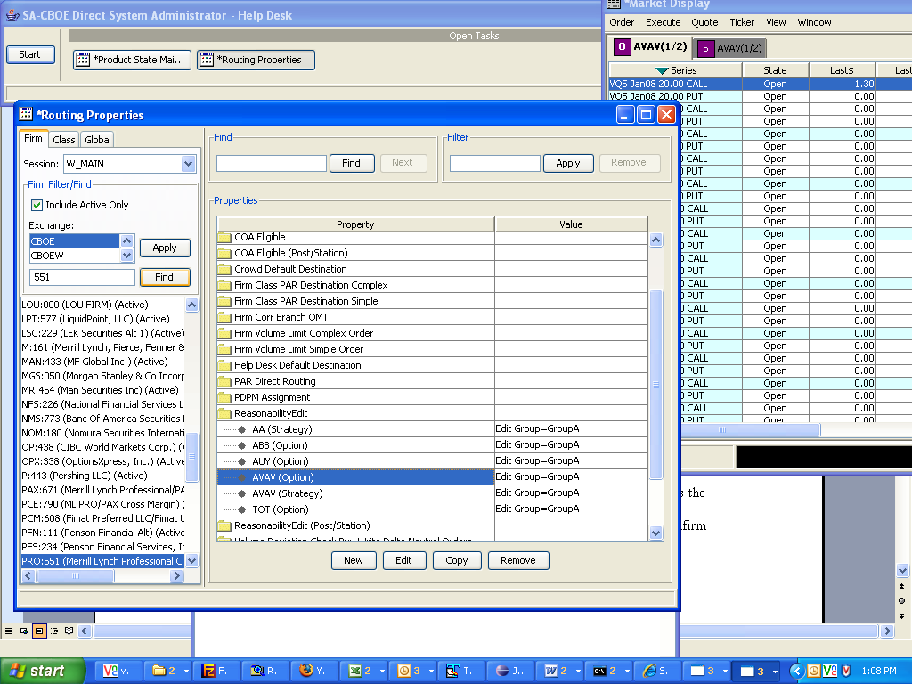

Route a complex order and note down the branch:seq. Let Server support verify that the range was picked from the DSM and not from the order price.
PITS 12015:
Pick a series and quote 1- 1.2 X100
Route a BUY order to PAR with the price 1.35.
Change the market to 1.25 -1.35 X 100.
Now “select” the order and trade it from PAR.
This fill should not generate a trade through.
You can view the tt_indicator on the order history screen and it should be marked as false.
Confirm through the TFL application (Call Narayan Sunder) to confirm the same

Pick a series and quote 1.25- 1.35 X100
Route a BUY order to PAR with the price 1.35.
Change the market to 1 – 1.2 X 100.
Now “select” the order and trade it from PAR.
This fill should generate a trade through.
You can view the tt_indicator on the order history screen and it should be marked as true.
Confirm through the TFL application (Call Narayan Sunder) to confirm the same

PITS 12136:
Pick a strategy product.
Quote on the legs, 1 – 1.2 X 100 and 2 – 2.2 X 100
Route an order
Check the order history
The Leg level history events, New Strategy Leg Order, should contain these values in the BBO_BID and BBO_ASK columns
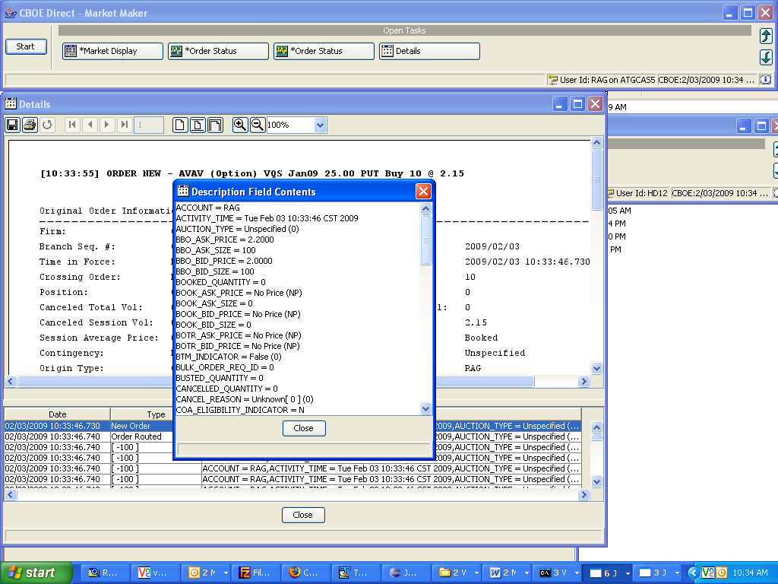
PITS 12109:
Action | Book | Result
Enter Quote  1.00-1.20 100x100 | 1.00-1.20 100x100 | Current Market is:  1.00-1.20 100x100
Enter “C” Order from CMI/FIX:  Buy 1.30 x100 | 1.00-1.20 100x100 | Order goes to PAR  Verify order is on PAR by using IQOD and PAR Terminal
At the time the Broker selects the order CBOE quote is  1.00-1.20 100x100  Broker fills the order for 100 at $ 1.25 | 1.00-1.20 100x100 | Fill Trade Report is sent back to CMI/FIX for 100  Verify fill report is published on the Status Window  Verify that in Market History and Order History for the product the Trade Through Flag is checked  Verify Alert Message is generated and sent to the Alert terminal through OHS  The scenario above should create a book trade through as well. Talk to Narayan Sunder to set up the TFL application * to view the same  See below about the set up for ATG5
The following test case will create both Firm Quote trade through as well Book trade through.

Kristy:
We are using the Market Replay browser-based application to check processing of this alert test case. While an OMT will show the alert (if one is set up for that environment), we are doing our testing through CDB.

To see if the alert is created and replicated into the CDB, you can bring up Internet Explorer with the following URL:

http://atgmrweba:5087/

A login screen will be displayed. Use the following test username and p/w to log in:

Username: mrtester4
Password: cboe1234

There will be a delay while the program logs in and sets itself up -- not too long, but noticeable. When login completes, a parameter selection screen will appear. Then do the following:

- Go to the section on the left side where a checkbox says "Near Real Time:" and click the box to remove the check mark. When the "Start Time:" becomes white to allow entry, change the hour to something early ("00" will do) to display between that time and current time.

- Go to bottom right box of parameters marked "Market Replay Screen Selection" and click "Alerts". When the "Alert Type:" dropdown appears, click on the down arrow then select "Satisfaction Alert".

- Click on the "Retrieve" button to view satisfaction alerts. Your test case should display

Let me know if you have any issues with the above, and when you have your case entered. We want to run our Market Monitor app to process this alert, and our TFL app to see the results -- after the alert is created.

Thanks.

Steve Bogolub, 312-786-7127
Systems Regulatory Development
TestCase1:

Create a P order from CMI and fill it in the outside exchange. This fill report SHOULD be published in the order status channel
Make an outside exchange price better.
Run the following ar command in the BC where the OHS is located:
ar OHServerHybrid modifyExpirationtimer P 60000

Put a pstop on the hub simulator (call Raghu if there are questions about putting pstop)

Route a P order from the trader gui to that particular exchange for that price

Log out the user from the trader gui.

Release the pstop on the hub simulator.

Log back into the trader gui.
Open the order status window.
You should see the fill report for this order (with poss.resend)

Testcase2:

For a P/A order, the fill report should NOT be published in the order status channel.
(Repeat the same test for a P order)
Route a customer order to PAR when the outside exchange is better.
If you cannot see the current market (i.e. Outside exchange is not NBBO, then stop, there is an issue, Call Support)
telnet to the BC which "holds" the class you are trading
go to run_dir/sql folder
type in loginDb W_MAIN
at the prompt: type
@support_getUnAckRptsDetail
Note down the count - A

Fill the order in the outside exchange.

go to run_dir/sql folder
type in loginDb W_MAIN
at the prompt: type
@support_getUnAckRptsDetail
Note down the count - B

The counts A and B should be the same (Assuming no one is testing.
Atleast you should not see an entry for the user that you logged in
PAR)

PITS: ? STP orders routing to PAR issue
When a stop order is direct routed to par, it is sent as an activated stop order, even when market conditions have not met activation rules.
TestCase:
Put a quote 1.00 - 1.20 100x100
Direct Route order to par to BUY 10 x 1.70 STOP
The order SHOULD not flash on par
(If same order type is sent to trade engine, the order rests as expected waiting to be activated.)

Test Scenario for the PITS#12329 – “The CBOE Direct is not generating FQ or NBBO TT alerts for single-listed classes for simple orders.”

Test Setup

- NONE

Test Case:

- Pick a Product that’s single-listed.
- Using trader GUI put a Quote of 1.00x100 – 1.20 x100 on that Product.
- Enter a simple (Customer) Order ‘C’ Buy 100@1.25 with direct route to Par workstation W080.
- On PAR workstation select the Order and put the Trade Price 1.25 for your Broker.
- Endorse the Trade for manual fill (ignore any endorse warning).

Verification:
- From the order status window, select OrderHistory menu item from the popup window by right-mouse click on the order.

- From the list of order history events, you can double click the Execution event and TT Indicator will be true.

- Also Check the Market History on Current Market the last sale “L” will have TT Indicator checked.

